Artboard 1

3501 McGillivray Blvd Winnipeg, MB R3Y 1G5

Malach NEMA Enclosures
Our Goal is to provide companies North America wide with products that exceed expectations. Malach can build any size enclosure from standard
to Custom. Powder coated steel, aluminum or Stainless. We ensure that our products are the right fit for companies and their customers every time.
*All photo samples are from our 3D CAD drawing system

Our goal is to become the number one choice for all sheet metal fabrication services across North America!

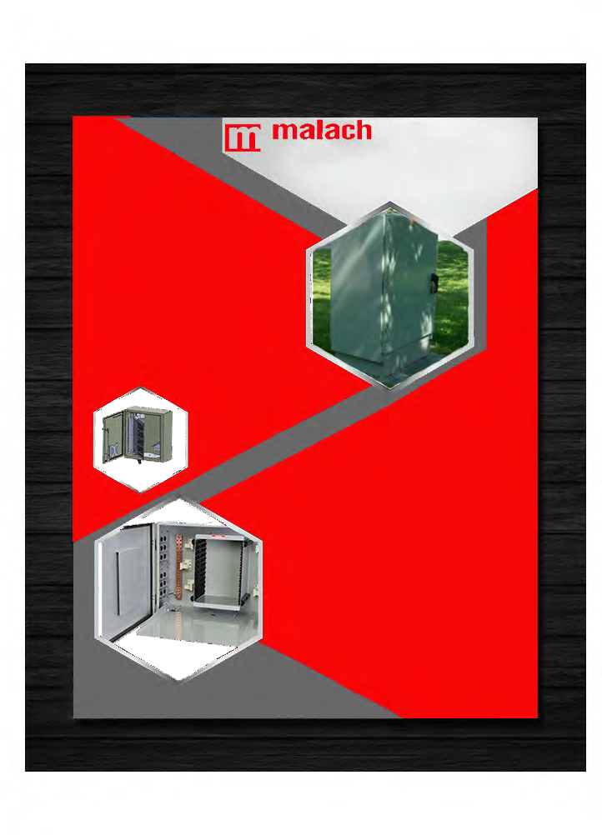

www.malachmetal.com
We offer a revolutionary pour in place robotically applied gasket on all our doors to ensure every cabinet meets or exceeds all Nema 3,4 and 4x requirements. To create our durable, long-lasting Enclosures, we use north American sourced steel, aluminum, and Stainless steel.

Advantages of Malach.
Pricing: By focusing on the newest technology and following our lean philosophy we ensure a competitive price every time.

Quality: Our Enclosures are some of the strongest and most durable in the industry.

Delivery: Our lead times are quicker than the competitors. with one, two- and three-week delivery programs.

Options
Custom Coating including Anti-Graffiti
3501 McGillivray Blvd Winnipeg, MB R3Y 1G5
Custom Solutions
Whatever you need, Malach can make it happen!

Buy America compliance manufacturing plant based out of Valley City, North Dakota.
Dependent on location, we offer direct-to-site delivery via our own trucks to ensure the best service possible from start to finish.

Our Standard
We pride ourselves on our quick turnaround time while providing great products and services to all industries across North America. As well as working with the customer from start to finish on every project. Our goal is to become the number

Engineering / Design Services
Our in-house engineering team is able to custom make any design.

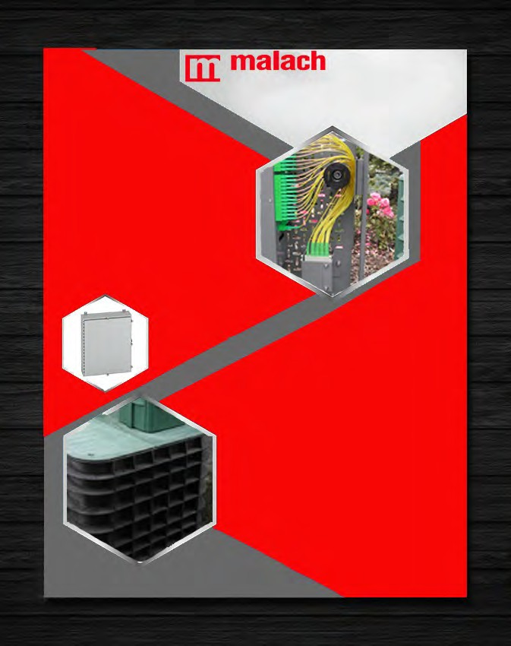

www.malachmetal.com
With over 60 years of experience in manufacturing and engineering, our team brings custom designs to life, building to customer specification while still maintaining strength within any structure.
Our Vision
By remaining relentlessly committed to new technological solutions, delivering high quality products and parts and complete customer service, we will be recognized as the partner of choice in the industries we serve.
Samples
If you are interested in a sample of our panels, please contact us and we would be happy to provide you with a scaled sample of our panels
Malach Metal & Machining is a company based in Winnipeg,MB, that has been in the sheet metal industry for over 50 years. We are new to the Nema 3 ,4 and 4x enclosure space however we have over 20 years’ experience in the enclosure field.

Find out why Malach is the right fit for you today

